**Brandon Hobbs**

**CS-340**

**September 21, 2022**

**Week 4 CRUD**

Driver to test the AnimalShelter Class an its Get and Set Methods

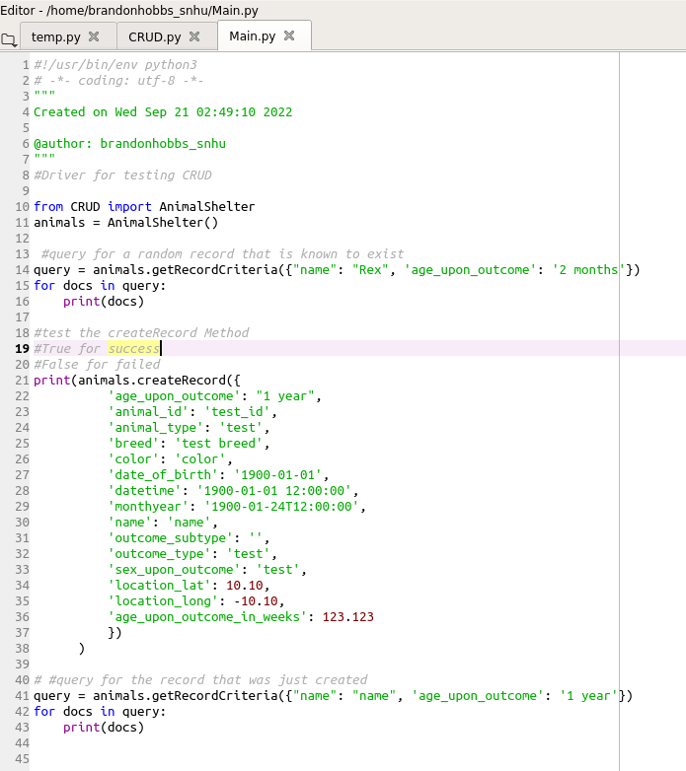

Console Output after running Driver

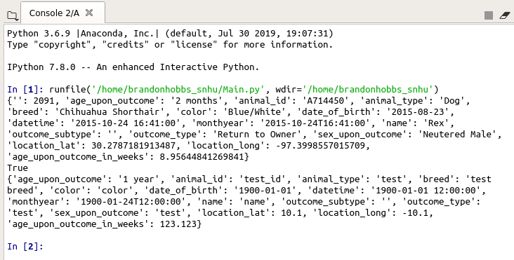

Query for “Rex”

Bool for createRecord

Query for newly created record